January 12, 1989

Smelter No. 14/89

by C. Viljoen

Distribution

P.J.V. Kinver

E.H.O. Meyer

H.P. Smit

A. Sousa-Poza

R. Haegele/File

J. Rennie/File

Smelter File

**SLAG FUMING PROJECT**

**PLASMA FUMING TEST RESULTS - MINTEK 3.2 MVA PLASMA FURNACE**

This report serves as a preliminary analysis of the test data for the two 3.2 MVA plasma furnace slag fuming test campaigns conducted by MINTEK in December 1988. The final report by MINTEK on the above subject will be issued at the next Sponsors Meeting on January 27.

A short summary of the test results is appended. More detail could be obtained from the computer files on the above subject.

1. Introduction

A total of 148 tons of selected blast furnace slag, crushed and screened to 100% minus 6mm as well as 9.8 tons of locally produced charcoal, crushed and screened to minus 6mm plus 2mm, was dispatched to MINTEK for a continuous fuming campaign on their 3.2 MVA plasma furnace. Analysis of the samples representing these slag and charcoal consignments are attached in TABLE 1.

The objectives for the envisaged test campaign were:

1. To prove that the excellent previously obtained (small scale) metal extractions could be consistently reproduced on the pilot plant scale during an extended operating period.

2. To, due to the envisaged length of the campaign, improve on the poor previously obtained metal accountabilities.

3. To verify the effectiveness of charcoal as a reductant.

4. To produce a sufficient quantity of fume for the envisaged hydrometallurgical pilot plant test work. The target was set at 10 tons.

5. To obtain data for the specification, costing and design of the industrial size (10-20 MVA) unit.

The target operating level was set at 0.8-1.0 MW.

6. To establish operational problems e.g. refractory wear, taphole problems, pipe blockages, etc.

A hot commissioning run (campaign 1) was conducted in November. This had to be terminated after 38 batches (taps) due to a complete refractory lining failure. After replacing the furnace shell and refractories, the actual run (campaign 2) commenced in December. This campaign had, however, also to be stopped prematurely after 69 batches due to refractory failure at the taphole. A total of 81.7 tons slag only was treated during the two campaigns, with 10.8 tons of fume being produced.

2. Equipment Design

2.1 Feed Equipment

The feed slag and charcoal were proportioned from separate bins with variable amplitude vibratory feeders onto a common conveyor belt. (See Figure 1) The conveyor belt discharged via a bucket elevator into a surge bin. Surge capacity was controlled with level switches, i.e. whenever the level in the surge bin was too low, the slag and charcoal vibratory feeders, conveyor belt and bucket elevator were activated.

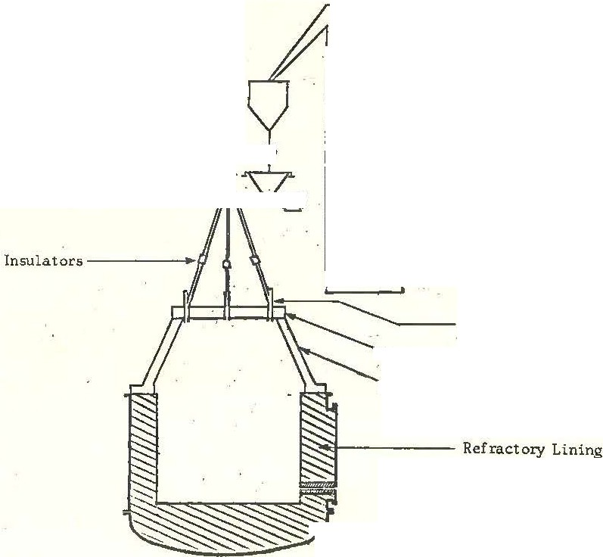

Surge Hopper -------< I

Bucket

Elevator·

Elevator

Slag Bins -

OJarcoal Bins

Ball Valve ,oo

Feed Hopper ­

Vibratory Feeder ,;;;;:;;;;

Feed Ports

-._ Flat Roof·

- Conical Roof

---- Furnace Bottom (Anode)

FIGURE 1. MINTEK 3.2 MVA Plasma Furnace - Feed arrangement

was actuated by a low/high feed hopper mass reading. Feeding from the feed hopper was via another vibratory feeder into a splitter box discharging by gravity into the furnace three equal streams.

Insulators had to prevent stray arcing equipment.

installed on all feed from the flat roof to pipes to the feed

2.2 Furnace and Refractories

The furnace consists of 4 main sections (see Figure 1): furnace bottom (anode), shell, conical roof and flat roof.

Both the conical and the flat roof is water cooled and is lined on the inside with refractory castable. The furnace off gas duct (water cooled) is situated in the conical roof while the flat roof contains the electrode {cathode) stuffing box and the three feed ports. Alumina silicate fiber sheets (Fibrefax) were used as insulation between the flat and conical roof and also between the conical roof and the furnace shell. This was to prevent stray arcing.

Two differently designed furnace shells were used. The first, used for the hot commissioning run (see Figure 1), was an air cooled shell of 1.0 m diameter. Guntap ramming material (Vereeniging Refractories) was used for lining of the anode bottom and sidewalls of the furnace to an inside diameter of 1.5 m. This is a high magnesite refractory.

A cylindrical zirconia lined alumina tapblock (Vereeniging Refractories) was initially installed. This tapblock, however, failed after 8 taps. It was replaced by a silicon carbide tapblock which lasted 5 more taps. The graphite tapblock, installed next, lasted for 18 taps. By this time the sidewalls, especially in the taphole area were severely eroded away so that the last two tapblocks installed before the campaign was terminated, lasted for only 3 and 4 taps respectively.

Inspection of the furnace afterwards revealed that the refractory lining was chemically attacked at the slag line, obviously aggravated by the high working temperatures required, i.e. 1500 deg c. Tsumeb blast furnace spent slag does exhibit an acidic nature as can be seen from the following (campaign average) analyses: 14.5% Fe, 15.8% Si, 18.8% ca and< 1% Zn. The high magnesite (basic) lining used for campaign 1 was thus not the ideal choice.

For the actual campaign (campaign 2) the air cooled furnace shell (described above) was replaced by a water cooled (film) shell of 1.8 m diameter. The furnace bottom was lined with Basiram (Cullinan Refractories) which is a chromag ramming material. The sidewalls were brick lined to an inside diameter of 1.3m with Vereeniging Refractories1 Standard grade chromag wedges.

was actuated by a low/high feed hopper mass reading. Feeding from the feed hopper was via another vibratory feeder into a splitter box discharging by gravity into the furnace three equal streams.

Insulators had to be prevent stray arcing equipment.

installed on all feed from the flat roof to pipes to the feed

2.2 Furnace and Refractories

The furnace consists of 4 main sections (see Figure 1): furnace bottom (anode)r shell, conical roof and flat roof.

Both the conical and the flat roof is water cooled and is lined on the inside with refractory castable. The furnace off gas duct (water cooled) is situated in the conical roof while the flat roof contains the electrode (cathode) stuffing box and the three feed ports. Alumina silicate fiber sheets (Fibrefax) were used as insulation between the flat and conical roof and also between the conical roof and the furnace shell. This was to prevent stray arcing.

Two differently designed furnace shells were used. The first, used for the hot commissioning run (see Figure 1), was an air-cooled shell of 1.0 m diameter. Guntap ramming material (Vereeniging Refractories) was used for lining of the anode bottom and sidewalls of the furnace to an inside diameter of 1.5 m. This is a high magnesite refractory.

A cylindrical zirconia lined alumina tapblock (Vereeniging Refractories) was initially installed. This tapblock, however, failed after 8 taps. It was replaced by a silicon carbide tapblock which lasted 5 more taps. The graphite tapblock, installed next, lasted for 18 taps. By this time the sidewalls, especially in the taphole area were severely eroded away so that the last two tap blocks installed before the campaign was terminated, lasted for only 3 and 4 taps respectively.

Inspection of the furnace afterwards revealed that the refractory lining was chemically attacked at the slag line, obviously aggravated by the high working temperatures required, i.e. 1500 deg c. Tsurneb blast furnace spent slag does exhibit an acidic nature as can be seen from the following (campaign average) analyses: 14.5% Fe, 15.8% Si, 18.8% ca and< 1% Zn. The high magnesite (basic) lining used for campaign 1 was thus not the ideal choice.

For the actual campaign (campaign 2) the air-cooled furnace shell (described above) was replaced by a water cooled (film) shell of 1.8 m diameter. The furnace bottom was lined with Basiram (Cullinan Refractories) which is a chrornag ramming material. The sidewalls were brick lined to an inside diameter of 1.3m with Vereeniging Refractories' Standard grade chromag wedges.

The chromag lining exhibited greater resistance to erosion than the pure magnesite lining in campaign 1. However, also in campaign 2 the graphite tapblock had to be replaced twice (after taps 28 and 42) and the campaign was terminated due to the third failure after 69 taps. The excessive use of oxygen for tapping and lack of tapping experience could only have contributed.

2.3 Waste Gas Handling Equipment

To prevent stray arcing the inclined waste gas duct (See Figure 2} was not connected to the furnace outlet duct. This duct was inclined to prevent dust settling. The afterburner (refractory lined) was designed also to serve as a dropout chamber. However, the damper at

The bottom of the afterburner was kept always closed. Temperatures as low as 150 deg c in the horisontal

section of the afterburner indicates that most of the afterburning occurred in the inclined duct. Afterburning was complete throughout the campaign.

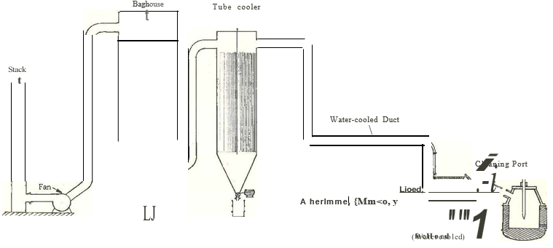

FIGURE 2. MINTEK 3.2 MVA Plasma Furnace Handling Equipment Waste Gas.

Downstream of the afterburner the gases were routed via double pipe water cooled duct for at least 10 meters. Gas cooling (not really needed) was affected with a forced draft tubular air cooler (waste gas inside tubes) and then filtered in a pulse air cleaned baghouse (Nomex bags) before stack discharge.

The only part of the waste gas equipment which tended to build up was the furnace outlet duct. The accretions were however easily removed between taps.

3. Metallurgical Results

3.1 Metal Extraction

Of the 107 batches treated (38 batches in campaign 1 and 69 batches in campaign 2) only 32 batches resulted in a spent slag analysis of less than 1% zinc. Average spent slag analyses and metal extractions from feed slag for both campaigns (TOTAL), campaign 1, campaign 2 and for the

32 less than 1% zinc-in-spent-slag batches (Selection) are shown below:

Spent Slag Analyses

Zn Pb Ge Ga

% % ppm ppm

TOTAL 2.1 0.3 71 214

campaign 1 2.0 0.3 63 219

Campaign 2 2.2 0.3 75 211

Selection 0.6 0.2 25 184

Metal Extractions

Zn Pb Ge Ga

% % ppm ppm

TOTAL 83.4 89.4 86.6 10.5

campaign 1 81.2 89.2 86.6 4.2

campaign 2 84.5 89.5 86.5 13.5

Selection 95.5 93.1 95.1 23.8

The Germanium content in spent slag is directly related to the zinc content in slag. This relationship is depicted in Figure 3.

Germanium vs Zinc content in Spent Slag

At Certain Carbon/Feed Slag Ratio

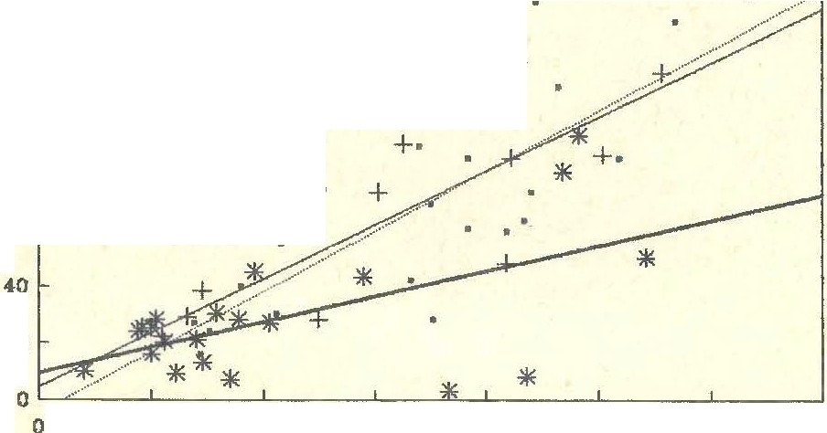

140

-···· 2.M,-3.0% C/1'8

-1- 3.0?.-3.5 C/FS

....

120 ¼ a.i; -4.0% C/FS

+

100

ao •

60

20

0.15

1

1.5

2

2.5

**3.5**

% Zinc 1n Spent Slag FIGURE 3.

Aiming for less than 1% zinc in spent slag should thus result in less than 25 ppm germanium provided that sufficient reductant is available. Lead extractions from slag were good regardless of the residual zinc in spent slag. Finding the optimum operating conditions for zinc extraction would thus optimize extraction of Germanium and lead as well.

Figure 4 summarizes the effect of carbon content in furnace feed and various tapping on the extraction of zinc from slag:

**Zinc in Spent Slag vs Charcoal in Feed**

**At Certain Tap Temperature Ranges**

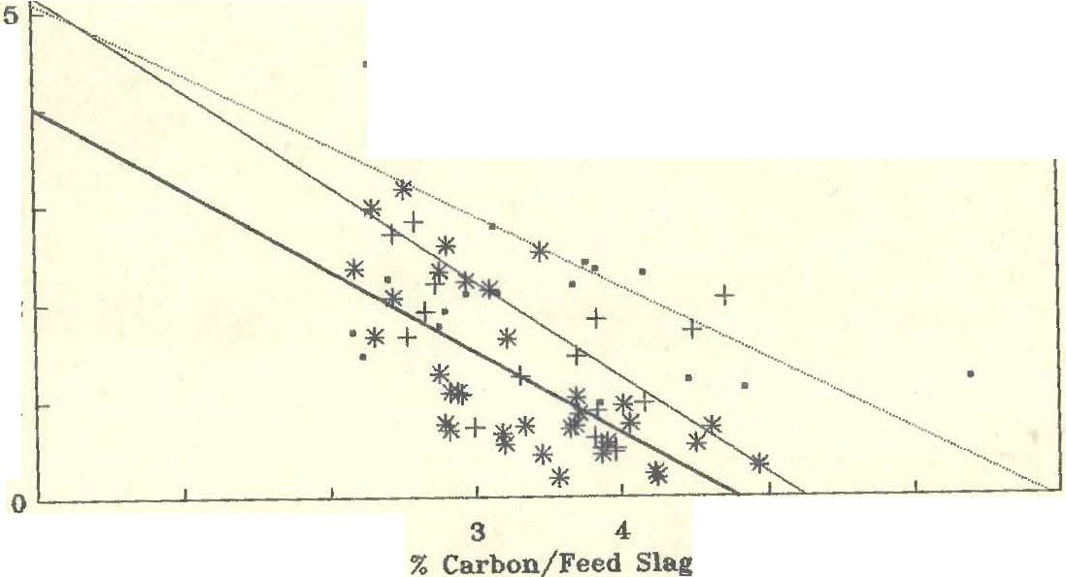

6 ;..:.%_Z:.:in=-:c_i_n_S..:.p_en_t*_s_1a_*.*:*.*g:: ..--------:: ::::::==========-=,--,*

**4**

+ +

+ +

**3**

**2**

**1**

**0**

**1**

**2**

**5**

**6**

**7**

1400-UM deg C

-4- 1460-1MO deg C

**4-** 1500-1600 **deg** C

FIGURE 4.

Clearly a tapping temperature of at least 1500 deg c is required at a carbon to feed slag ratio of 4% to obtain less than 1% zinc in spent slag. Carbon efficiency decreases with decreasing temperature. Charcoal was used as a reductant, which weighs less per unit volume than the coal/char utilized in the previous tests resulting in a visible layer of unreacted charcoal observed towards the end of campaign 2.

3.2 Metal Accountability

Metal accountabilities to spent metal recoveries to fume for slag and fume as well as both campaigns (TOTAL), Campaign 1, Campaign 2 and the 32 follows: selected "good" batches.

Accountability to Slag and Fume

Total mass Zn Pb Fe Ge Ga

% % % % % %

TOTAL 100.7 90.3 77.3 86.6 40.0 94.3

campaign 1 102.0 81.6 62.7 91.8 34.4 98.7

Campaign 2 100.1 94.5 84.4 84.1 42.7 92.1

Selection 101.5 84.8 78.5 79.4 31. 7 81.9

Metal recovery to Furne

Zn Pb Fe Ge Ga

% % % % %

TOTAL 73.7 66.7 0.4 26.6 4.7

campaign 1 62.8 51.9 0.4 21.1 2.8

Campaign 2 79.0 73.9 0.4 29.2 5.6

Selection 80.3 71.6 0.5 26.8 5.7

Accountability of the total mass was good, which suggests that the weighing of feed materials and final products were satisfactory. However accountability for the individual metals was alarmingly poor especially the accountability for germanium (40%).

on three occasions were metal detected

i.e. campaign 1 Tap 8 : 134 kg

Tap 30 : 91 kg

campaign 2 Tap 40 : 207 kg Analyses of these metallic phases to the author. More of the metal accumulated in the furnace bottom. in the tapped slag, were not available phase could have The extraction of iron from feed slag as a function of the carbon content in feed is shown below for the averages of both campaigns, Campaign 1, Campaign 2 and the selected 32 good batches.(See Figure 5)

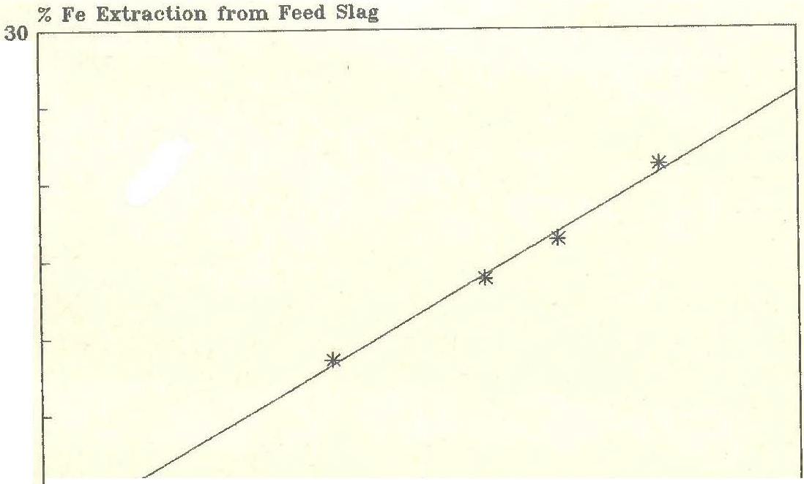

**25**

**20**

**15**

**10**

5

**0** L-------- ---L '1,. ,1,. ,

2 2.5 3 3.5 4

% Carbon/Feed Slag

FIGURE 5.

In section 3.1 of this report it was concluded that a carbon to feed ratio of 4% (at 1500 deg C tapping temperature) is required to obtain good paymetal extractions from slag. However, from Figure 5, a 4% carbon to feed slag ratio setpoint would result in 25% of the iron in feed slag being exracted with only 0.5% of the extracted iron reporting to the fume. The resultant metal phase will collect some of the extracted gallium and germanium. The reduced gallium acountability to slag and fume for campaign 2 and the Selection (which had high 3.4 and 3.6% carbon to feed ratios respectively) indicates that some of the gallium presumably "disappeared" to a metal phase. In an attempt to explain the low three of the fume samples laboratories for re-analysis. follows: germanium accountability were submitted to our The results compared as one of the objectives of this campaign was to produce sufficient fume {10 t}. A total of 10.8 tons of fume was produced but of very low Ge content. Average fume analyses were as follows:

**MINTEK TCL**

|  |  |  |  |  |  |  |  |
| --- | --- | --- | --- | --- | --- | --- | --- |
| Sample No | 1 | 2 | 3 |  | 1 | 2 | 3 |
| Zn,% | 62.0 | 63.7 | 63.0 |  | 61.6 | 62.7 | 61.7 |
| Pb, % | 13.7 | 13.3 | 15.2 |  | 14.0 | 13.4 | 15.4 |
| Fe, % | 0.64 | 0.63 | 0.65 |  | 0.86 | 0.85 | 0.79 |
| Ge,ppm | 700 | 830 | 780 |  | 565 | 680 | 740 |
| Ga,ppm | 84 | 98 | 80 |  | 72 | 77 | 70 |

Accountability for germanium and gallium based on TCL assays would even be lower.

3.3 Product quality

|  |  |  |  |  |  |
| --- | --- | --- | --- | --- | --- |
|  | Zn,% | Pb, % | **Fe,** % | Ge, % | Ga, % |
| Total | 64.3 | 12.8 | 0.45 | 971 | 72 |
| Campaign 1 | 64.5 | 12.0 | 0.54 | 921 | 56 |
| Campaign 2 | 64.2 | 13.4 | 0.40 | 997 | 81 |

The highest germanium content obtained for a single batch was 1820 ppm. Theoretically the fume should contain 2000 to 3000 ppm Ge.

Spent slag analyses were as follows:

|  |  |  |  |  |  |  |  |
| --- | --- | --- | --- | --- | --- | --- | --- |
|  | Zn,% | Pb, % | Fe, % | Si, % | Ca,% | Ge, % | Ga, % |
| Total | 62.0 | 63.7 | 63.0 |  | 61.6 | 62.7 | 61.7 |
| Campaign 1 | 13.7 | 13.3 | 15.2 |  | 14.0 | 13.4 | 15.4 |
| Campaign 2 | 0.64 | 0.63 | 0.65 |  | 0.86 | 0.85 | 0.79 |
| Selection | 700 | 830 | 780 |  | 565 | 680 | 740 |

The 32 selected "good" batches should represent what could be expected from the optimised eventual operation.

**4. Power Utilisation**

4.1 Heat Loss and Specific Energy Consumption

In order to obtain good metallurgical results (see Section

3.1} a tapping temperature of 1500 deg c is required. To achieve a specific tapping temperature, the power level and feed rate has to be closely matched. This is done by first selecting a power level and assigning a certain portion to heat losses. The remainder will then be available for smelting and fuming of the slag.

The energy requirement for the smelting and fuming of the slag was initially incorrectly estimated at 0.7 kWh/kg. It was then changed to 0.6, 0.5, 0,45, 0.5 and eventually

2.65 kWh/kg feed slag. This resulted in large variations of the heat loss estimations in an endeavour to obtain the required tapping temperature.

To make all data points comparable the author has back calculated the estimated heat losses as if a constant specific energy consumption of 0.65 kWh/kg slag was used throughout. The results were plotted against the actual obtained tapping temperature for campaign 1 and 2. see Figures 6 to 9.

**TapTemperature vs Estimated Heat Loss**

**400 kW, Campaign 1**

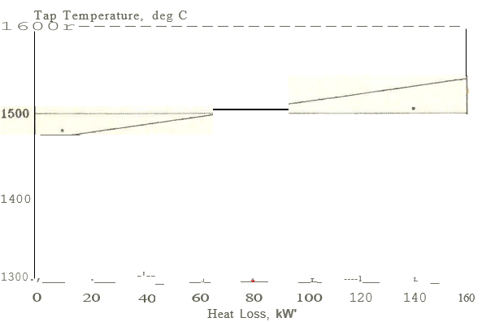

**Figure 6**

**Tap Temperature vs Estimated Heat Loss**

**500 kW, Campaign 1**

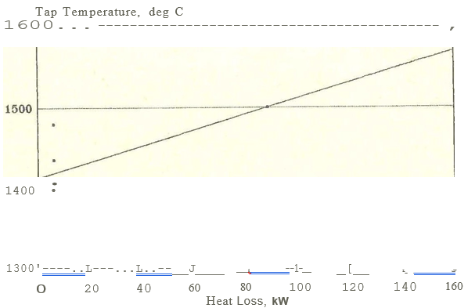

**Figure 7**

**Tap Temperature vs Estimated Heat Loss**

**500 kW, Campaign 2**

**Figure 8**

**Tap Temperature vs Estimated Heat Loss**

**600 kW, Campaign 2**

**Figure 9**

By assuming a specific energy consumption of 0.65 kWh/kg slag, the heat losses to be estimated to obtain a tapping temperature of 1500 deg C could be read from Figures 6 to 9, the results of which are summarised in Figure 10. This graph also displays actual measured heat losses for campaign 2. These data points were obtained from cooling water temperature measurements for the furnace sidewalls, conical roof, flat roof and waste gas outlet duct.(An estimation had to be made for the heat lost through the bottom of the furnace). The average distribution of heat lost by the various sections of the furnace were as follows:

|  |  |
| --- | --- |
|  |  |
|  |  |
|  |  |
|  |  |
|  |  |
|  |  |